Apply filters to SQL queries

Project description
You are a security professional at a large organization. Part of your job is to investigate security issues to help keep the system secure. You recently discovered some potential security issues that involve login attempts and employee machines.
Your task is to examine the organization’s data in their employees and log_in_attempts tables. You’ll need to use SQL filters to retrieve records from different datasets and investigate the potential security issues.
In this scenario, you need to obtain specific information about employees, their machines, and the departments they belong to from the database.
Your team needs data to investigate potential security issues and to update computers.
You are responsible for filtering the required information from the database.
Here’s how you’ll do this task: First, you’ll retrieve all failed login attempts after business hours. Second, you’ll retrieve all login attempts that occurred on specific dates. Third, you’ll retrieve logins that didn't originate in Mexico. Fourth, you’ll retrieve information about certain employees in the Marketing department. Fifth, you’ll retrieve information about employees in the Finance or the Sales department. Finally, you’ll obtain information about employees who are not in the Information Technology department.

Retrieve after hours failed login attempts
Your team is investigating failed login attempts that were made after business hours. You want to retrieve this information from the login activity. You’ll identify all unsuccessful attempts after 18:00.
The login_time column in the log_in_attempts table contains information on when login attempts were made. Office hours end at '18:00'.
The success column in the log_in_attempts table contains values of TRUE or FALSE to indicate whether the login was successful. MySQL stores Boolean values as 1 for TRUE, and 0 for FALSE. This means that TRUE is represented as 1, and FALSE represented as 0 in the success column.
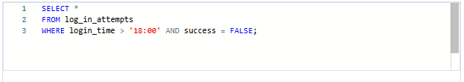

How many failed login attempts occurred after 18:00?
Answer: There are 19 failed login attempts that occurred after 18:00.

Retrieve login attempts on specific dates
Your team is investigating a suspicious event that occurred on '2022-05-09'. You want to retrieve all login attempts that occurred on this day and the day before ('2022-05-08').
The login_date column in the log_in_attempts table contains information on the dates when login attempts were made.
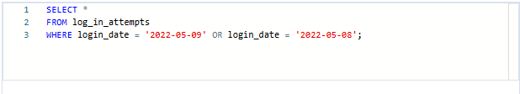

How many login attempts were made on these two days?
Answer: There are 75 login attempts in these two days.

Retrieve login attempts outside of Mexico
Now, your team is investigating logins that did not originate in Mexico, and you need to find this information. Note that the country field includes entries with 'MEX' and 'MEXICO'. You should use the NOT and LIKE operators and the matching pattern 'MEX%'.
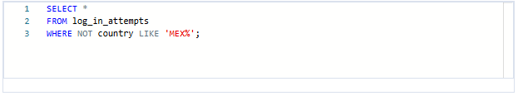
How many login attempts were made outside of Mexico?
Answer: There are 144 login attempts made outside of Mexico.

Retrieve employees in Marketing
Your team is updating employee machines, and you need to obtain the information about employees in the 'Marketing' department who are located in all offices in the East building (such as 'East-170' or 'East-320').

- Write a SQL query to retrieve this information from the employees table. Select all columns and include filters on the department and office columns to return only the needed records.

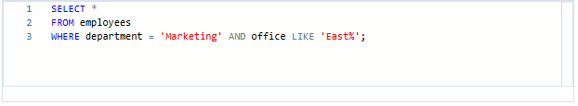
What is the username of the first employee in the Marketing department in the East building?
Answer: The username of the first employee in the Marketing department in the East building is elarson.

Retrieve employees in Finance or Sales
Now, your team needs to perform a different update to the computers of all employees in the Finance or the Sales department, and you need to locate information on these employees.
- Write a SQL query to retrieve records for employees in the 'Finance' or the 'Sales' department.
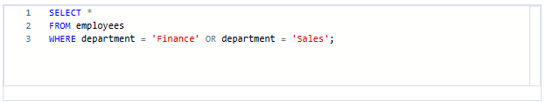

What is the username of the first employee in the Sales department returned by the query?
Answer: The username of the first employee in the Sales department is lrodriqu.

Retrieve all employees not in IT
Your team needs to make one more update. This update was already made to employee computers in the Information Technology department. The team needs information about employees who are not in that department. You should use the NOT operator to identify these employees.
- Write a SQL query to retrieve records for employees who are not in the 'Information Technology' department.
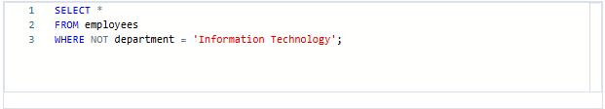

How many employees are not in the Information Technology department?
Answer: There are 161 employees who aren’t in the Information Technology department.

Summary
In this activity I acted as a security professional investigating potential security issues by applying SQL filters to query data from the employees and log_in_attempts tables at a large organization.

I used SQL operators including AND, OR, NOT, LIKE, and comparison operators to retrieve specific information such as the 19 failed login attempts that occurred after business hours (18:00), the 75 login attempts made on May 8th and 9th 2022, and the 144 login attempts that originated outside of Mexico.

I also filtered employee data to retrieve specific groups including Marketing department employees located in East building offices, employees in the Finance and Sales departments, and the 161 employees who were not part of the Information Technology department.

These SQL filtering techniques allowed me to efficiently investigate security incidents and identify the specific employee and login data needed to support the security team's investigations and system update efforts.

